Problem-13: A virtual memory management system in an operating system uses Least Recently Used (LRU) cache.

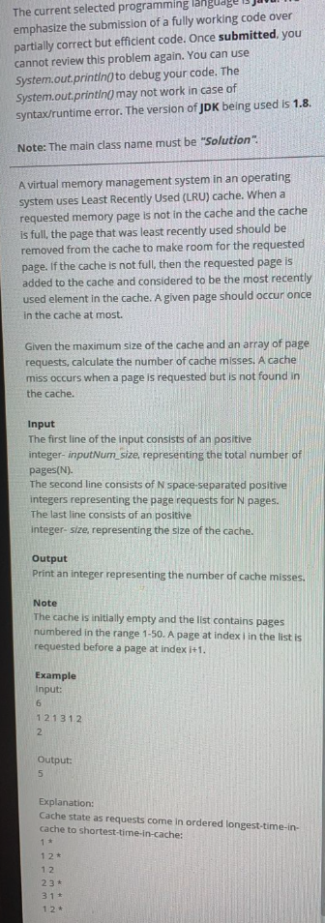 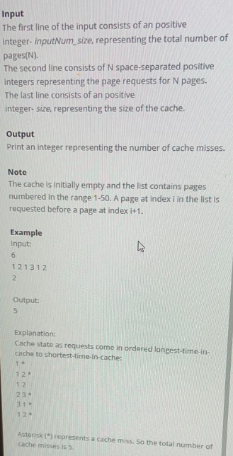

Consider the priority_queue<pair<int, int>> (descending order of age_bit) with <age_bit, page_no>, age_bit will be set according to operations (starting with 1 initially) and will not be updated if cache-hit is found.

Also, maintain, is_present_in_cache Boolean array, to keep track of page present in cache or not, because there is not O(1) peep operation in priority queue

When cache is full will remove the entry from map that has age_bit lowest!

In real LRU, you should also consider when hit is found and update the age_bit by +1

Youtube Link (OG question): Click [here](https://www.youtube.com/watch?v=Xc4sICC8m4M&list=PLgUwDviBIf0p4ozDR_kJJkONnb1wdx2Ma&index=77).

Problem-0: Bob has to send a secret code S to his boss. He designs a method to encrypt

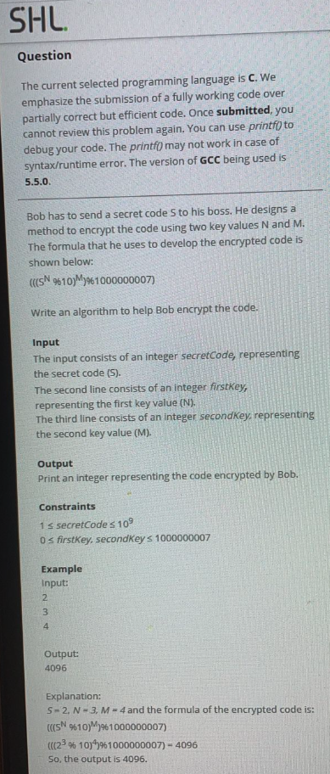 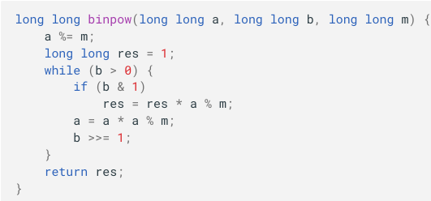

Problem-1: GCD of N positive integers.

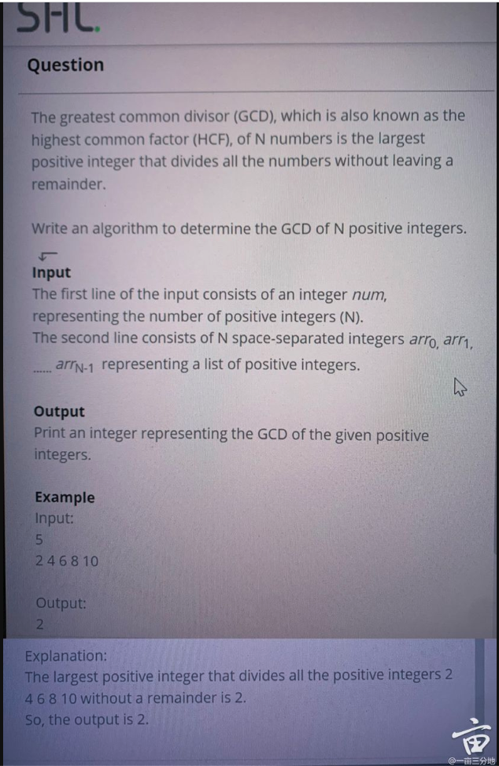

Solution: __gcd(m, n)

Problem-2: The manager of the grocery company tagGrocery wishes to identify…

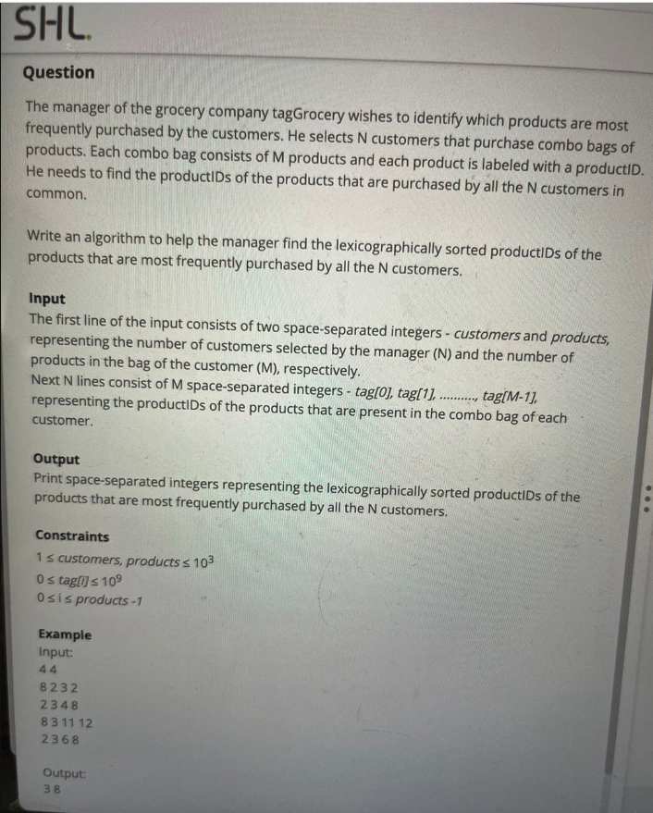

Maintain unordered_map<pid, cnt> and for each customer create new array because customer can purchase same product multiple times thus we don’t want to do cnt++ in unordered_map!

Problem-3: Martin’s Father goes for a jog every morning.

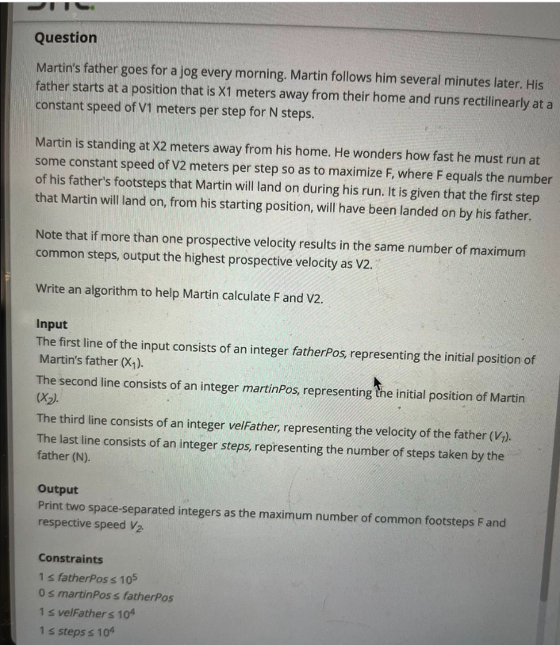

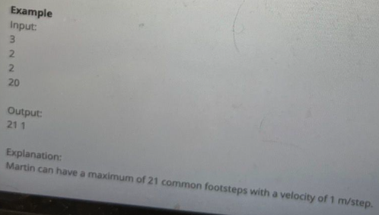

<https://leetcode.com/discuss/interview-question/827362/oa-question-2020>

Problem-4: A company sells its products at N outlets. All the outlets are connected to each other by a series of roads. There is only one

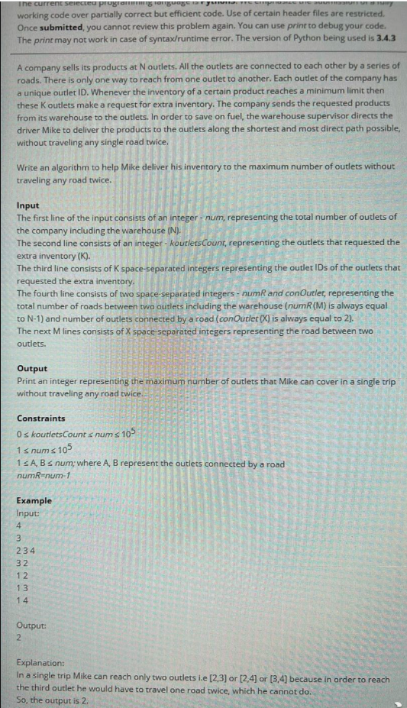

Build the graph (edgelist). And also maintain the degree of vertexes.

Out of given outlets (requested), perform bfs with any of the vertex having degree=1, and pass on the distance to neighbouring nodes, increase the distance only if you encounter the requested node and so on.

At last check the highest distance marked for requested node that will be the answer.

Only 1 BFS required that’s it.

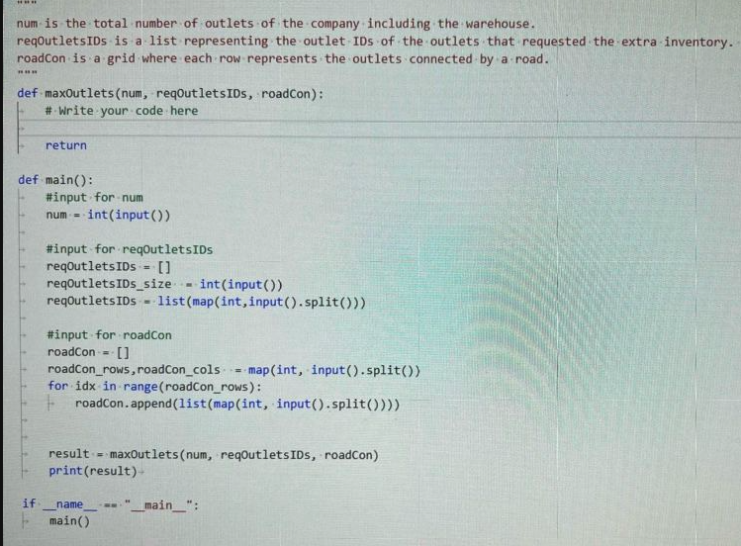

Problem-5: The city authorities are examining the houses in a residential area for a city planning

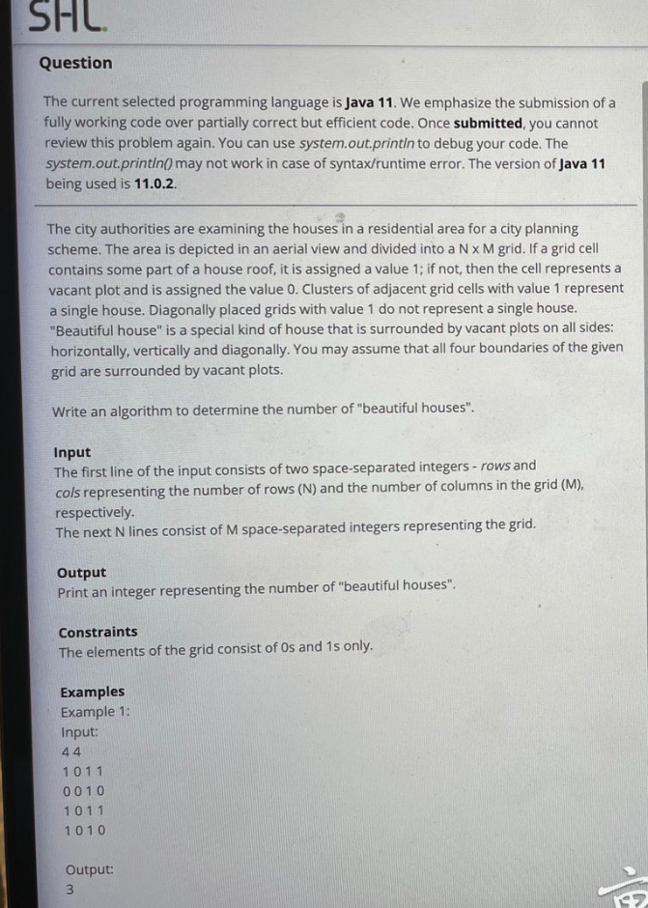 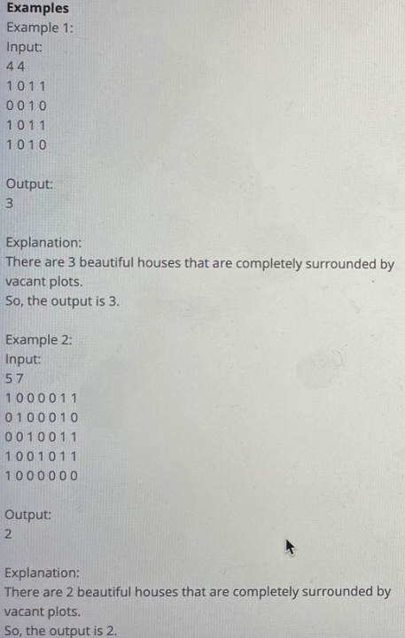

Solution: multi-source BFS, start with any non-zero cell and mark it with that particular number, jitne number bangene vahi hai answer.

Note:Before all that remove all those 1s whos all four directions has 0’s! why? Because one 1 is not house, atleast 2 chahiye ones (and vo bhi diagonally nahi, left right up down) mai 1s chahciye.

Problem-6: A colony of eight houses, represented as cells, are arranged in a straight line.

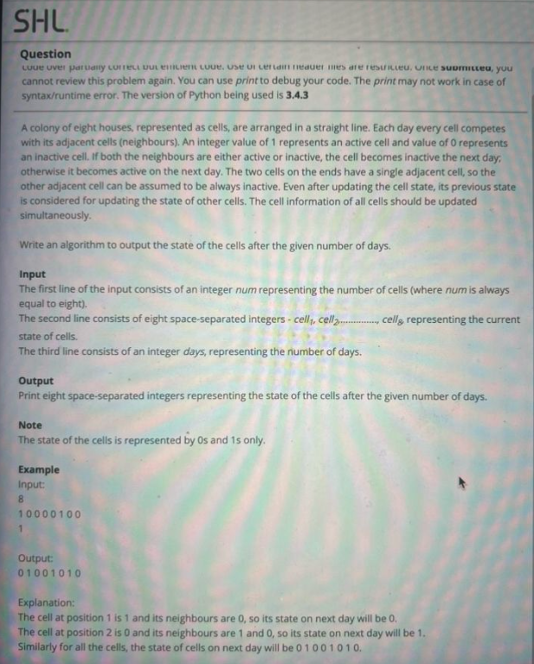

Solution: straightway implementation.

Problem-7: In a town, the houses are marked with English letters. A town committee wants to renovate each house.

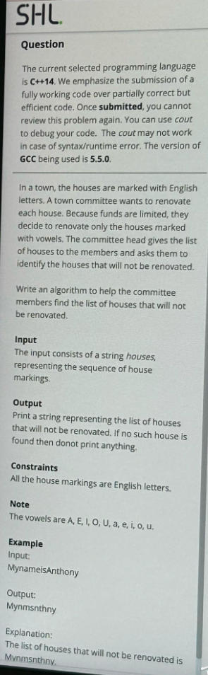

Solution: straightway implementation.

Problem-8: Emerson is very fond of strings, and he keeps trying to reverse them.

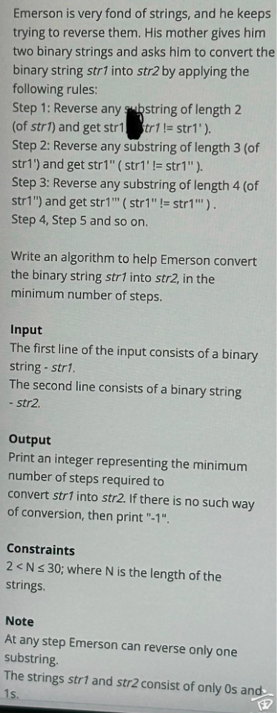

Problem Link: Click [here](https://stackoverflow.com/questions/46233522/find-minimum-steps-required-to-change-one-binary-string-to-another)

Problem-9: Allie is working on a system that can allocate resources to the applications in a manner efficient

 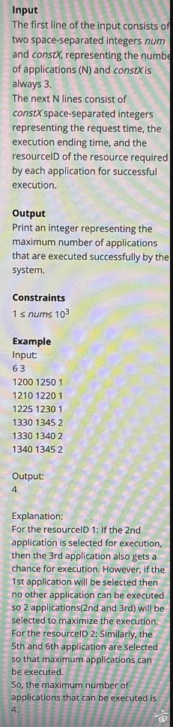

Solution: <https://leetcode.com/discuss/interview-question/1621080/SAP-Labs-or-OA-2021-or-Maximum-Executed-Applications/1708623>

Problem-10: In a city there are N houses. Noddy is looking for a plot of land in the city on which to build his house.

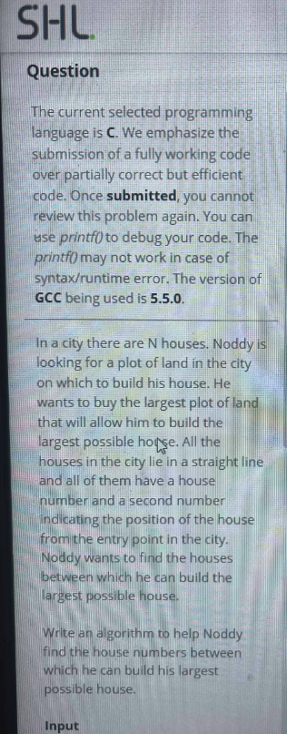 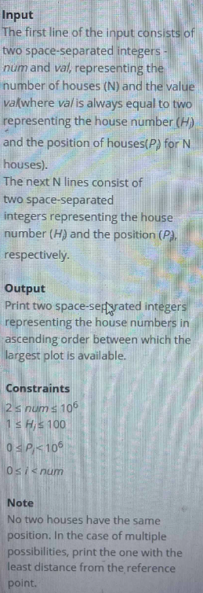 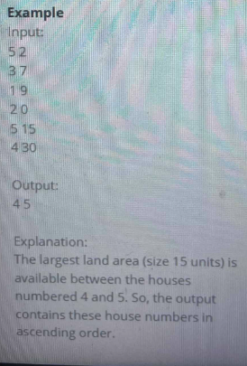

Solution: straight way, vector<pair<int, int>> = {{position, house_no}} sort it by position.

Problem 11: Mary, a physical education teacher, divides her students into different groups and assigns an ID to each group.

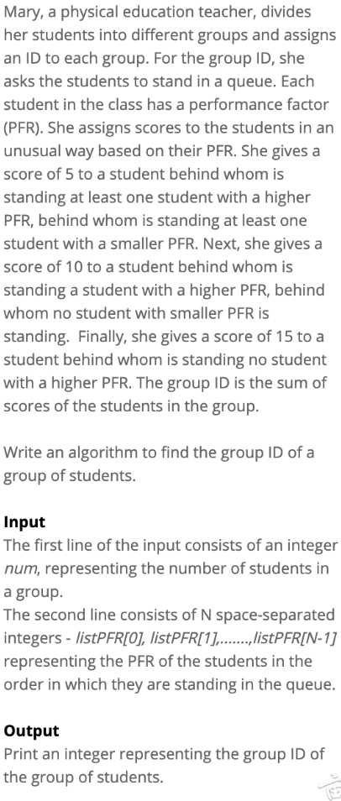

Solution: simple straight implementation, maintain small and larges PFR for each index from right to left and assign score accordingly.

Problem-12: A transportation company wishes to begin service in the city of Nazeriana.

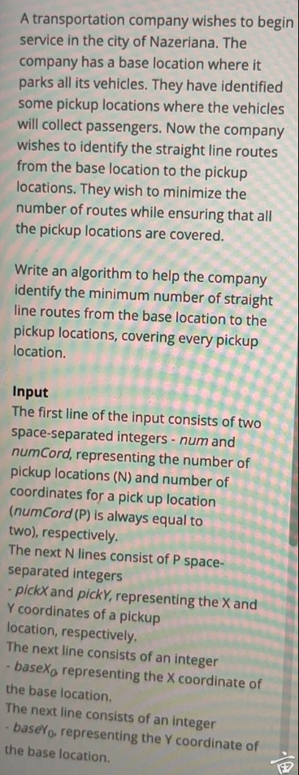 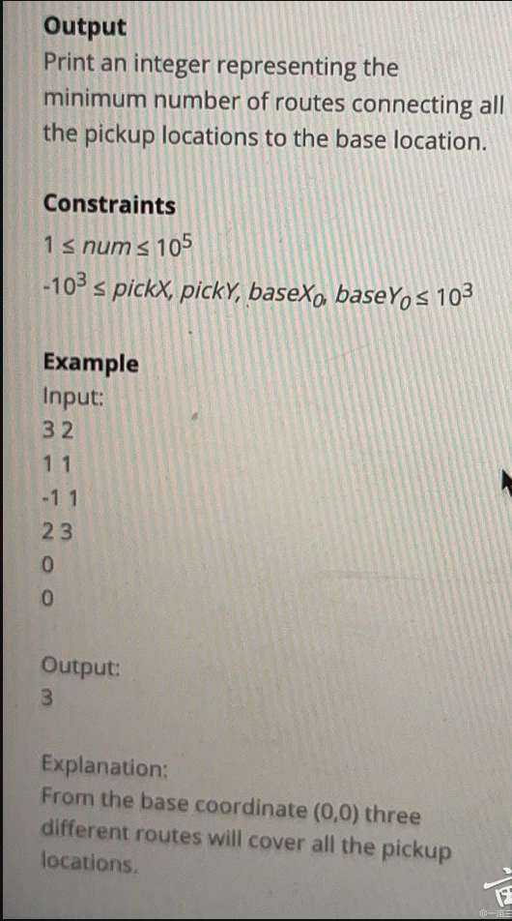

Good question:

Link1: [votrubac1](https://leetcode.com/problems/minimum-lines-to-represent-a-line-chart/solutions/2061824/gcd-slope/comments/1614476), Learning out of this problem – float division (a/b) (c/d) never compare because of rounding error! Instead follow this way. [Link3](https://leetcode.com/problems/minimum-lines-to-represent-a-line-chart/solutions/2061824/gcd-slope/comments/1401407)

Problem-14: Mr. Jason has captured your friend and has put a collar around his neck. He has locked it with a given ‘locking key’.

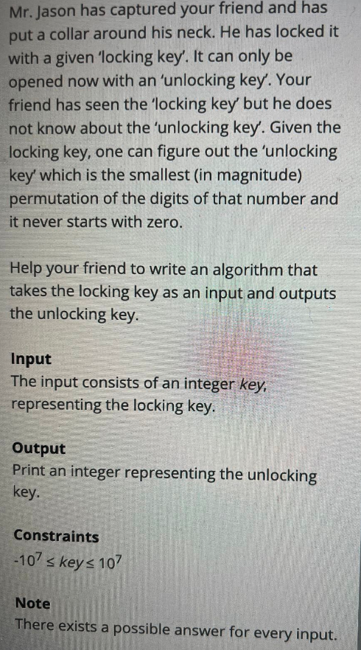 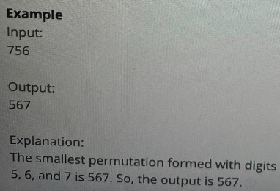

Solution: straight way.

Maintain 0-9 indices array mark the occurances, first start with 1 and then 0 and then 2, 3, 4 …9

Problem-15: A mouse is placed in a maze. There is a huge chunk of cheese somewhere in the maze.

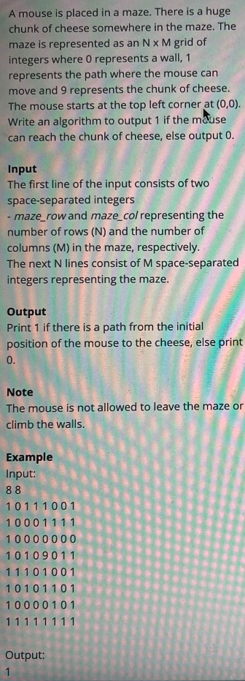

Solution: BFS